**Wei Liang** **SP17**

**CST 2309-E286**

**Lab#9**

**Prof. Sancar Avcioglu March 8, 2017**

**Lab#9 [Google Chrome]**

**Question 1:**

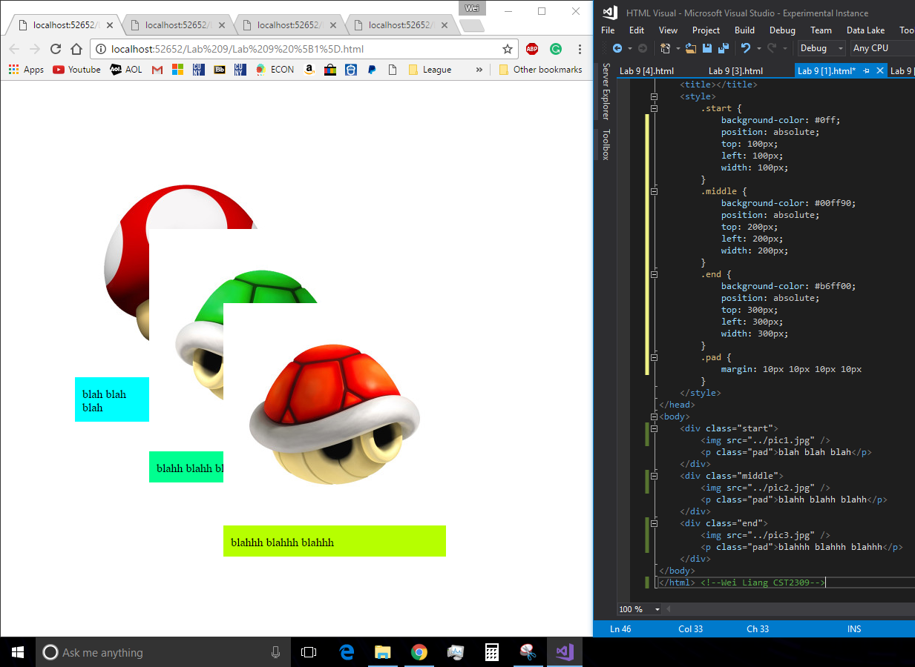

**Question 2:**

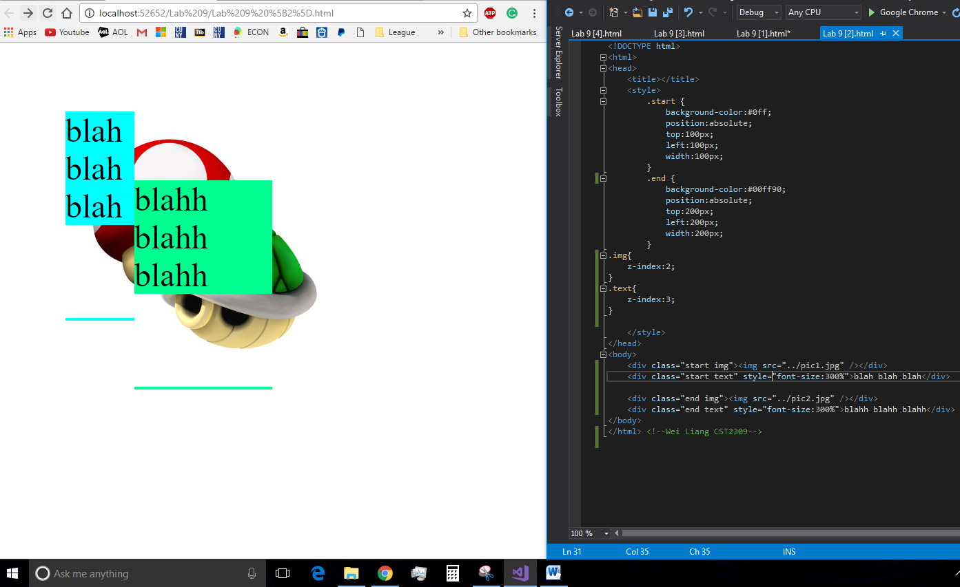

**Question3: Full Screen VS 75% Screen VS Half Screen**

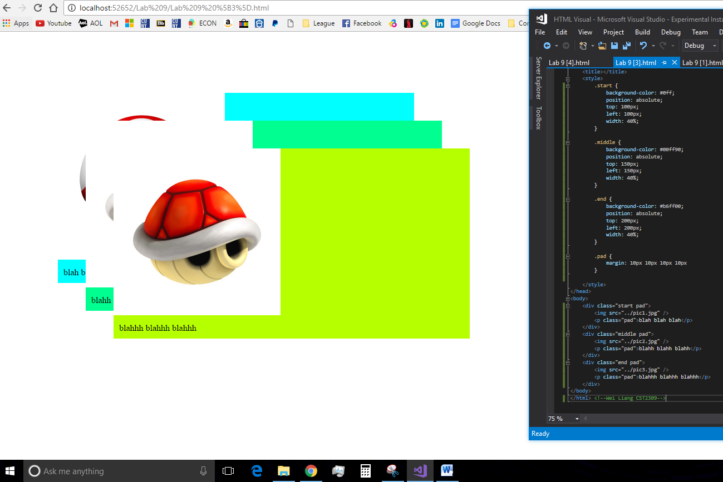

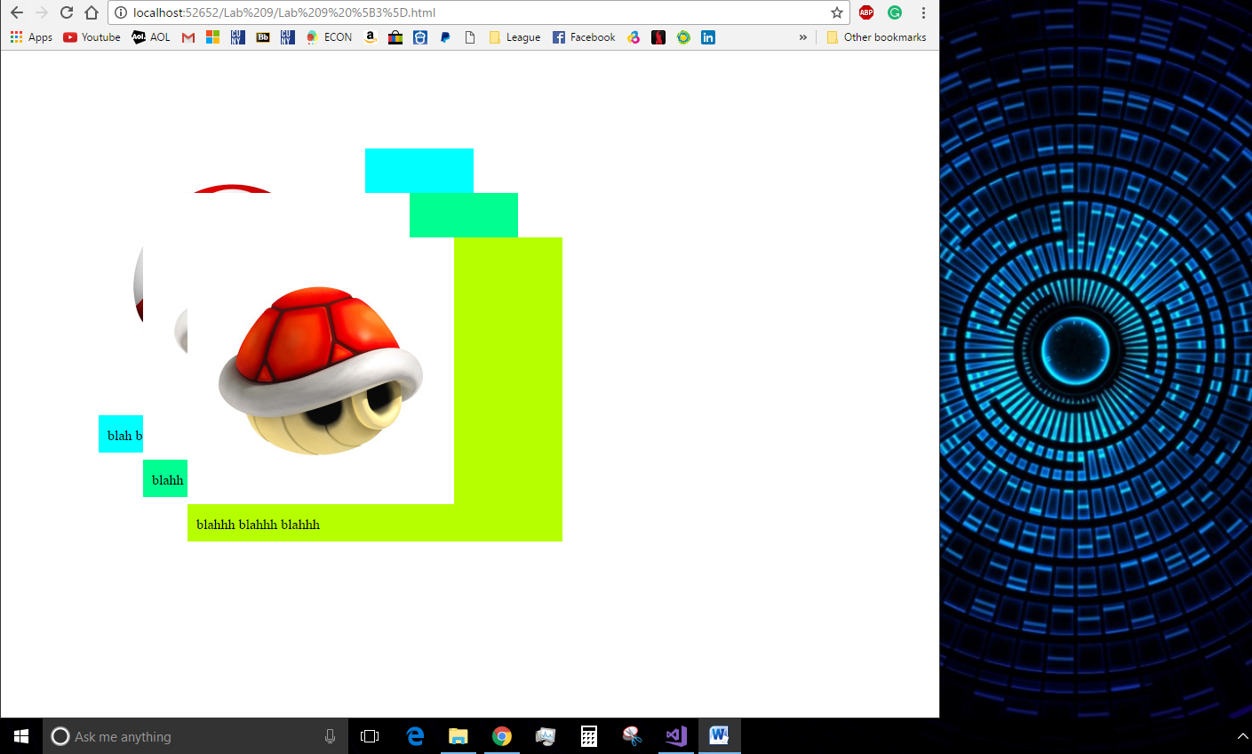

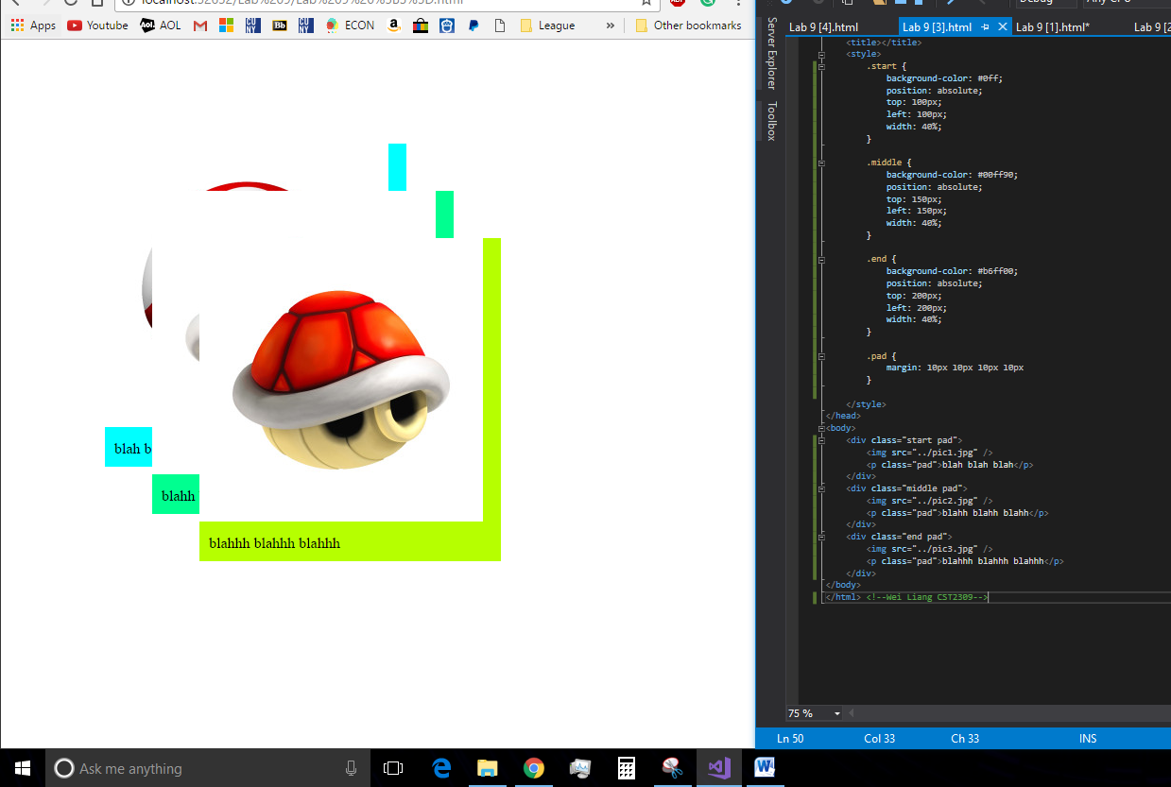

**Question 4: Without hovering over images and after**

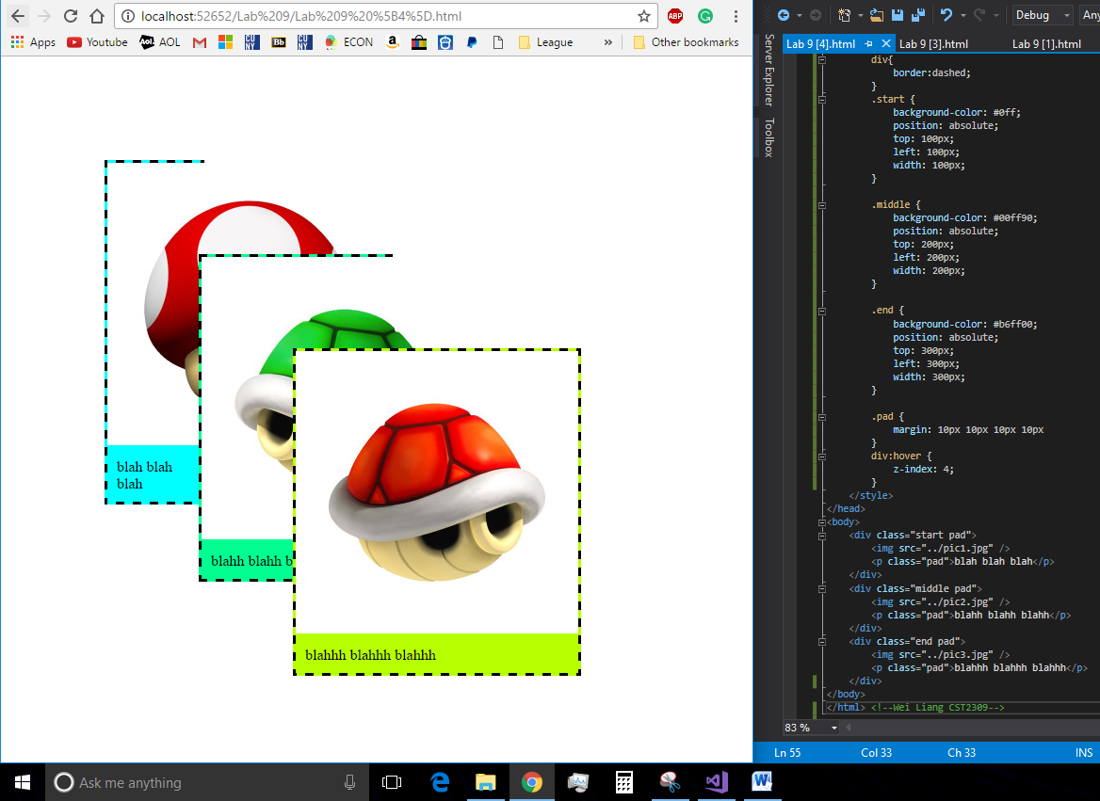

[Unable to SS Mouse through Print Screen or Snipping Tool]

